**Salmon Habitat Mapping in the Central Kenai Peninsula 2021-2024**

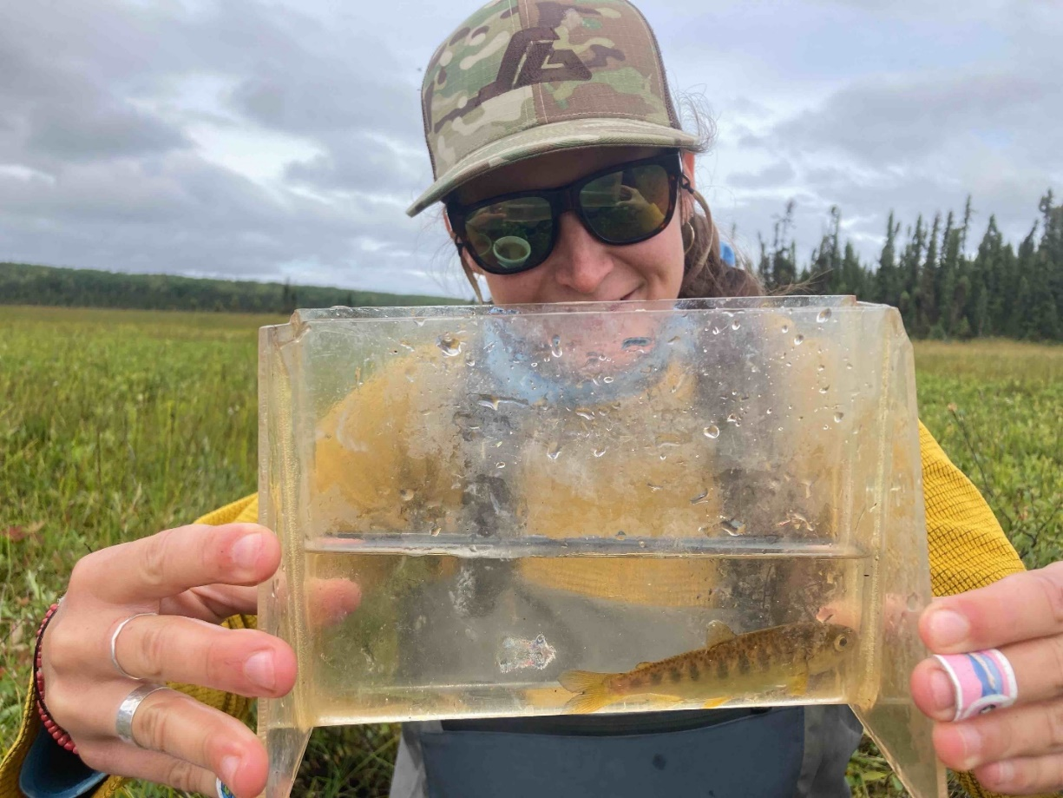

October 25, 2024

Benjamin Meyer

  
[www.kenaiwatershed.org](http://www.kenaiwatershed.org)

***This report is best accessed on the web as an interactive document at   
https://kenai-watershed-forum.github.io/salmon-habitat-mapping/***

**Executive Summary**

It is estimated that less than half of Alaska’s freshwater salmon habitat is officially documented by the Alaska Department of Fish and Game, and until these streams and lakes are inventoried, they will not be afforded certain protections under Alaska state law.

Two nonprofits in the central Kenai Peninsula region, Kenai Watershed Forum and the Kenai Peninsula Chapter of Trout Unlimited, are collaborating to address this data gap by working with volunteers to document local salmon habitat. From 2021 - 2023, we identified 17.5 miles of stream and 1152 lake acres of previously undocumented anadromous habitat in areas within a thirty-minute drive of Soldotna, Alaska.

Given that so much undocumented salmon habitat was so close at hand prior to this project, our results highlight the need to continue this work and strengthen connections between habitat researchers and managers. Going forward in summer 2024, we are working with map specialists to apply predictive habitat occupancy models that will help to target and prioritize our fieldwork. If these models prove successful, we anticipate that in the future they may have broad application throughout Alaska, for researchers as well as within regulatory and permitting regimes.

**Table of Contents**

Introduction …………………………………………………………………………………… 5

Methods ……………………………………………………………………………………….. 9

Results ………………………………………………………………………………………… 13

Discussion ……………………………………………………………………………………... 18

Future Directions ………………………………………………………………………………. 26

References ……………………………………………………………………………………… 32

Appendix A – Supplemental Tables …………………………………………………………… 34

**Notes on Previous Versions of this Report**

This document serves as the final report for work conducted from 2021 - 2023 to expand and corroborate the Alaska Department of Fish and Game’s Anadromous Waters Catalog in the central Kenai Peninsula area of Alaska, USA.

This document combines, replaces, and updates the following two previous reports, which can be disregarded as earlier versions:

* <https://bookdown.org/kwfwqx/tu_awc_expansion/>
  + Work funded by the [Kenai Peninsula Chapter of Trout Unlimited](https://kenaipeninsula.tu.org/) 2021-2022, with additional grants received from:
    - [Trout Unlimited Embrace-a-Stream](https://www.embraceastream.org/)
    - [Kenai Community Foundation](https://www.kenaicommunityfoundation.org/)
* <https://bookdown.org/kwfwqx/awc_expansion/>
  + Work funded by the [Alaska Sustainable Salmon Fund](http://www.akssf.org/About.aspx) project #54014, “Expanding and Corroborating the Known Extent of Anadromous Waters Throughout the Kenai Peninsula.”

# 1 Introduction

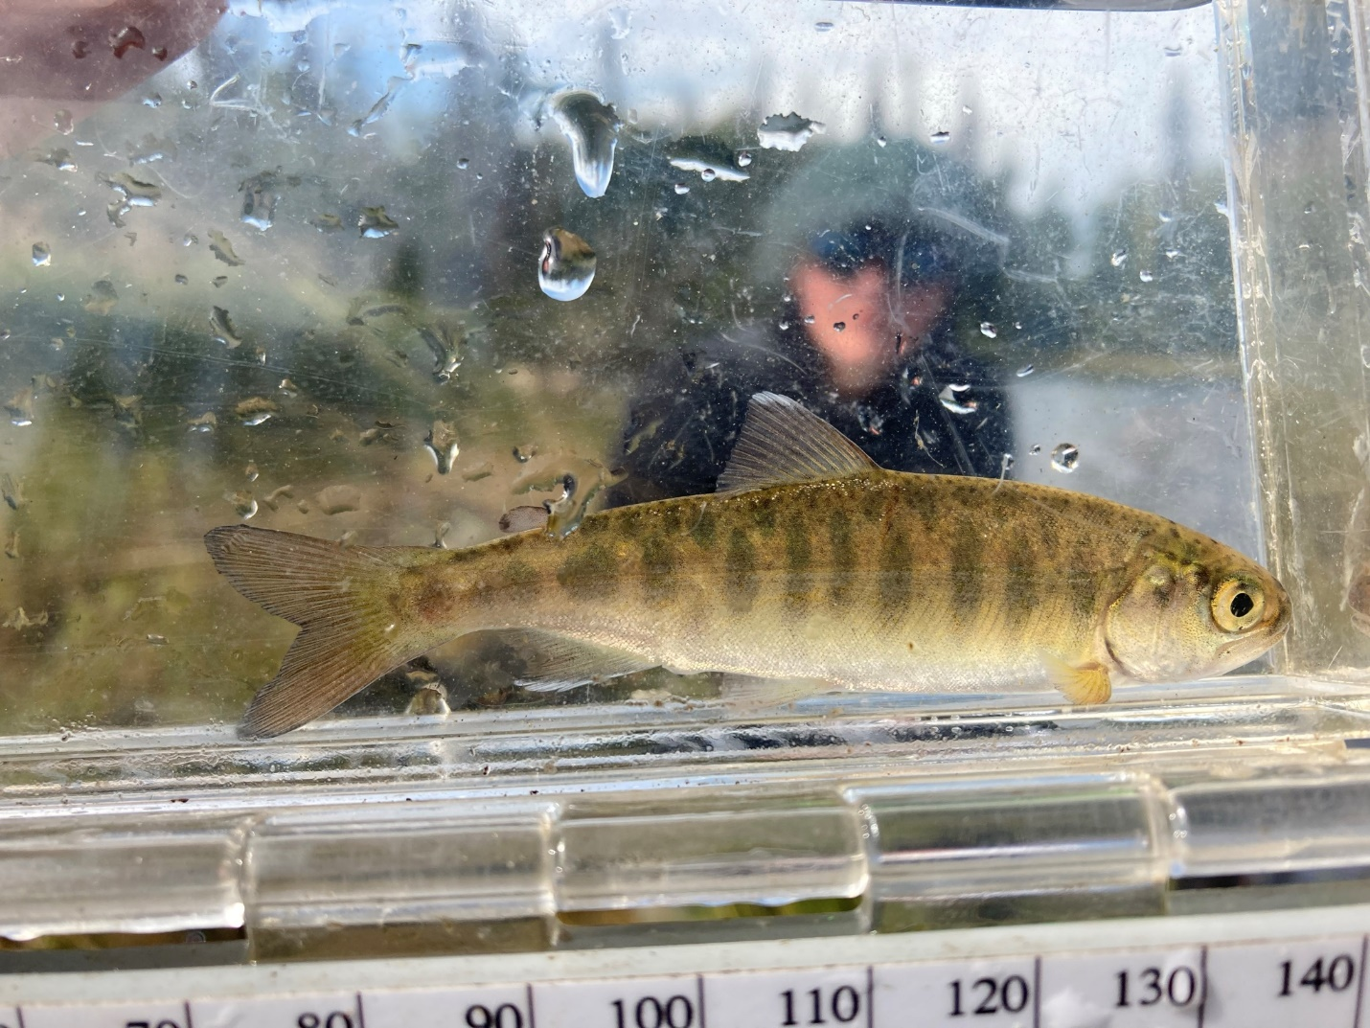

*Juvenile Coho Salmon*

## 1.1 Project Rationale

The Kenai Peninsula’s watersheds are significant producers of Pacific salmon. Critical to Alaska’s economic and cultural wellbeing, these salmon support fisheries both inland and throughout Cook Inlet. [Kenai Watershed Forum](https://kenaiwatershed.org/) (KWF) in collaboration with [The Kenai Peninsula Chapter of Trout Unlimited](https://kenaipeninsula.tu.org/) (KPTU) are documenting habitat for salmonid spawning, rearing, and migration in order to increase the known water bodies recognized in the Alaska Department of Fish and Game’s (ADF&G’s) Anadromous Waters Catalog (AWC). The AWC is Alaska’s most powerful tool for regulating, protecting, and conserving anadromous fish habitat.

Salmon are intrinsic to the cultural and economic well-being of Alaska, but cannot persist on the landscape without healthy habitat. Through strategic conservation efforts, riparian and instream habitat can continue to maintain salmon populations as well as transport marine-derived nutrients; maintain hydrology; and provide refuge during a rapidly changing climate.

In recognition of the importance of protecting anadromous fish habitat, the State of Alaska enacted [Alaska Statute 16.05.871](http://www.adfg.alaska.gov/index.cfm%3Fadfg=habitatregulations.prohibited)[1], “Protection of Fish and Game”, which requires the state to list rivers, lakes, and streams important for the spawning, rearing, or migration of anadromous fish, while also requiring the prior approval of construction or use of said waterbody that may result in adverse effects on salmon populations. In response, ADF&G began overseeing the AWC whose data is now publicly hosted online for resource managers and interested members of the public to utilize. See Figure [Figure 1.1](https://kenai-watershed-forum.github.io/salmon-habitat-mapping/intro.html#fig-awc-map) for ADFG’s online interactive map these data. Access the map at <https://bit.ly/awc_map>.

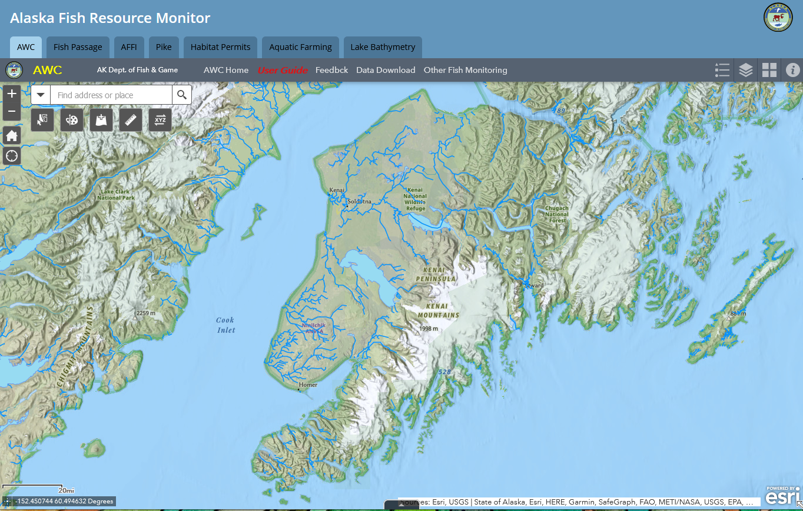

*Figure 1.1: The Alaska Department of Fish and Game’s Anadromous Waters Catalog online mapper. Access the map at* [*https://bit.ly/awc_map*](https://bit.ly/awc_map)*.*

Each year, ADF&G solicits anadromous stream nominations from statewide efforts from the previous year. Once accepted, these nominations are incorporated into the AWC and its associated atlas. To date, [the AWC includes nearly 20,000 anadromous streams, rivers, and lakes](https://www.adfg.alaska.gov/sf/SARR/AWC/index.cfm?ADFG=main.home)[2], though it is widely understood that this number represents [less than fifty percent](https://www.adfg.alaska.gov/sf/SARR/AWC/index.cfm?ADFG=nomSubmit.about) of anadromous waterbodies throughout the state[3]. While ADF&G is conducting efforts to update existing data and survey for previously undocumented habitat, there remains a vast number of water bodies in need of surveying and habitat use observations.

In response, this project proposed to collect new observations of fish habitat and submit them for inclusion in the AWC.

KWF worked with KPTU to strategically prioritize survey sites to collect data for AWC nomination submissions. Site prioritization was based on criteria including the increase in protected anadromous fish habitat, accessibility, and alignment of priorities with local agency and partnership goals. These are described in greater detail in the methods section. KWF coordinated with local agency partners to ensure that fieldwork efforts were not unnecessarily replicated.

## 1.2 Volunteer Training

On June 5, 2021 a half-day training workshop was conducted by Kenai Watershed Forum staff for fifteen Trout Unlimited volunteers, including but not limited to identifying ideal anadromous fish habitat; responsible deployment and retrieval of minnow traps; juvenile and adult fish identification; data collection and recording while in the field; and safe travel in bear country. Participants were introduced to an [Anadromous Habitat Survey Standard Operating Procedure](https://bit.ly/kwf_awc_sop) (SOP) document[4].

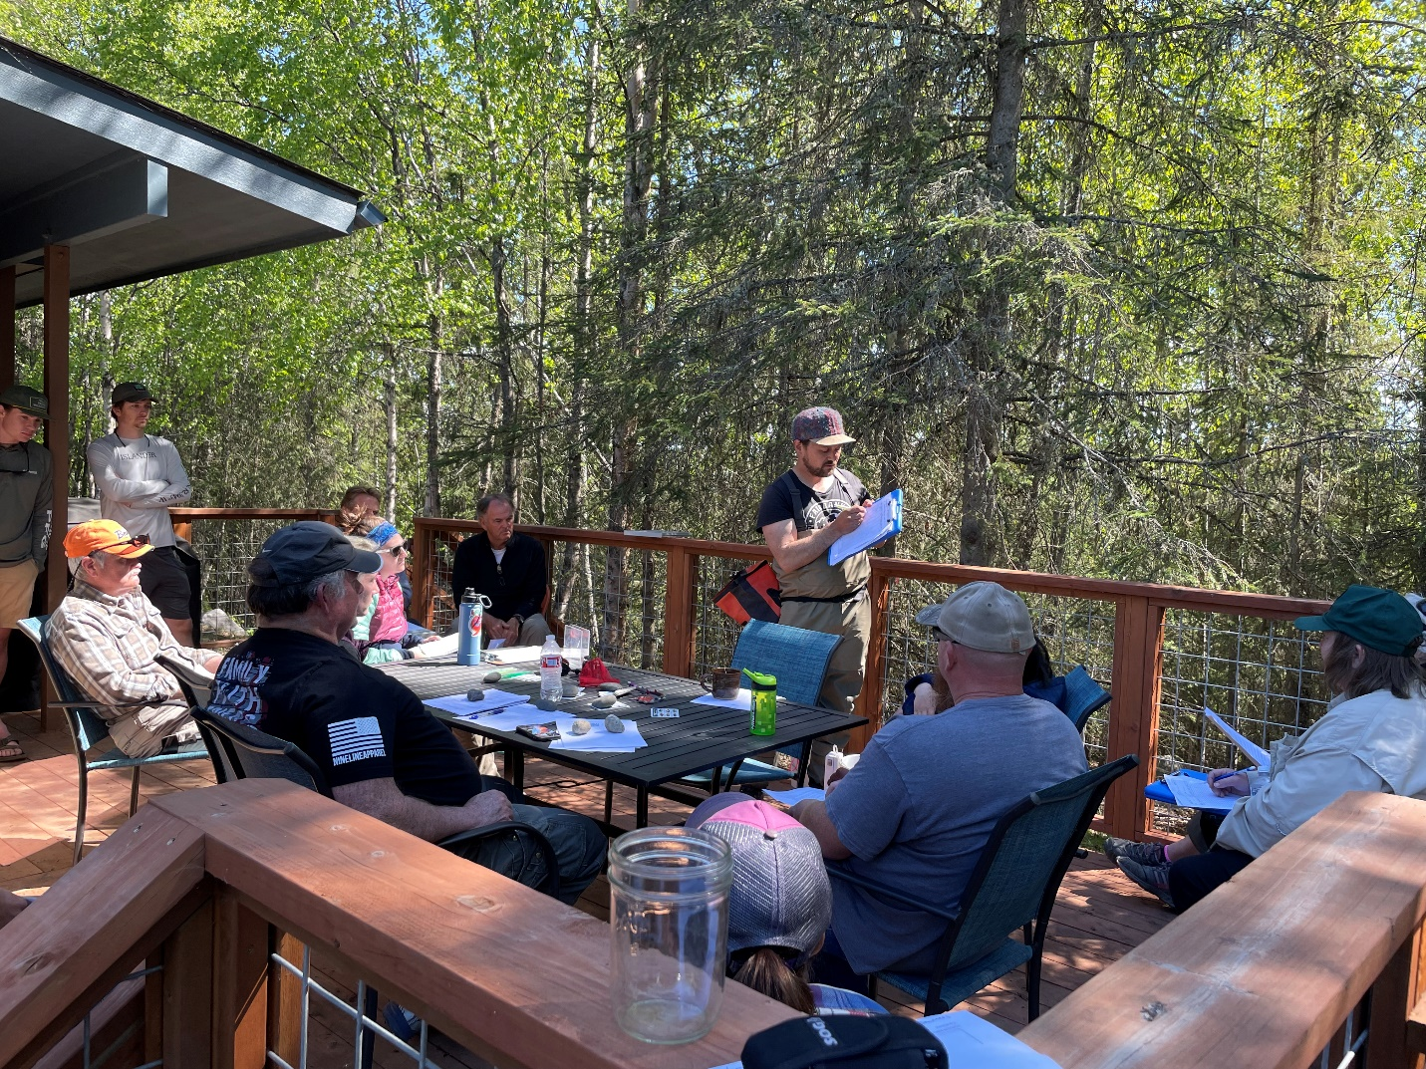

*Kenai Peninsula Chapter of Trout Unlimited Volunteers.*

## 1.3 Objectives

* Submit nominations to increase anadromous stream, river, lake, and wetland coverage in the AWC and corresponding atlas
* Revise or corroborate outdated AWC and atlas data, particularly on Kenai River tributaries experiencing increases in zinc concentrations as well as priority corridors identified by the Kenai Mountains to Sea partnership

# 2  Methods

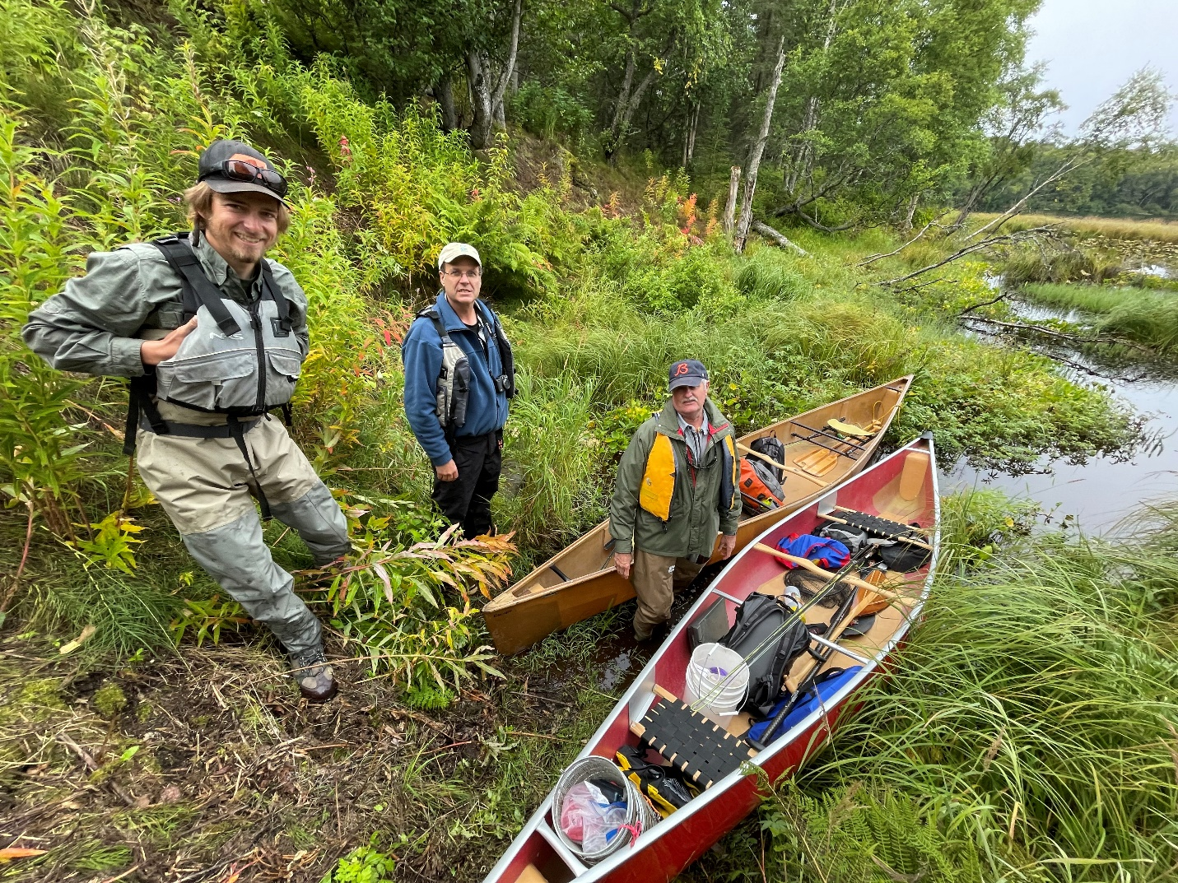

*Kenai Peninsula Trout Unlimited volunteers preparing for fieldwork at Suneva Lake in August 2021.*

## 2.1 Site selection

Fish habitat survey sites were identified using databases generated by Kenai Peninsula Trout Unlimited and Kenai Watershed Forum. Sites were further prioritized using the following criteria:

* Significant increase in protection of anadromous fish habitat through addition of new stream miles/lake acreage
* Ability to provide significant revision and/or data corroboration for outdated catalog data
* Ease of accessibility via foot travel based on travel time and ability to obtain private property access
* Proportion of stream or lake adjacent to developed parcels
* Habitat with medium-high risk assessment rating using the [Kenai Peninsula Fish Habitat Partnership’s “Freshwater Potential Threats Ranking Table](https://www.kenaifishpartnership.org/wp-content/uploads/2013/06/DRAFT-Freshwater-CAP_2014_solicitation.pdf)“[5]
* Alignment with fieldwork priorities of local resource managers as well as partnership efforts including those of Kenai Mountains to Sea (a prioritized corridor list can be found at <https://kenaiwatershed.org/science-inaction/mountains-to-sea/>) and Kenai Peninsula Fish Habitat Partnership (KPFHP)

### 2.1.1 Online Study map

The project study map may be accessed by following the link at [ArcGIS Online](https://experience.arcgis.com/experience/806e59bc0eac4713a26f1f03a76cf85a/)[6]. Following the link, the user can toggle layers on/off as needed.

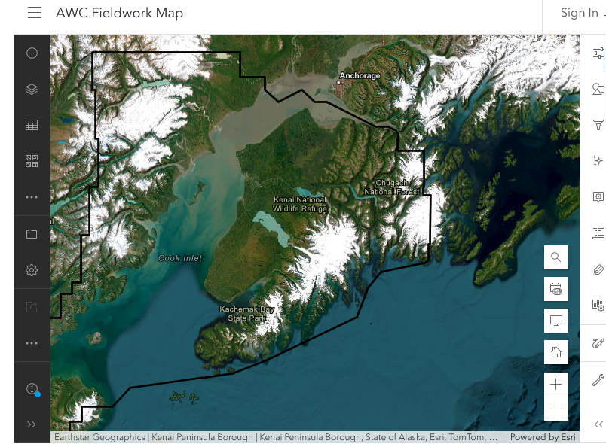

*Image of* [*ArcGIS Online project map*](https://experience.arcgis.com/experience/806e59bc0eac4713a26f1f03a76cf85a/)

Prior to minnow trap deployment, each year we obtained all necessary permits from ADF&G including the Aquatic Resource Permit (ARP). As required by the ARP, the ADF&G local Area Management Biologist was notified of trapping locations and timeframes before going into the field. We also obtained landowner permission for access to sites where applicable. Finally, trapping efforts for each day were strategically chosen based on proximity of sites so as to reduce drive and personnel time.

## 2.2 Fish capture and processing

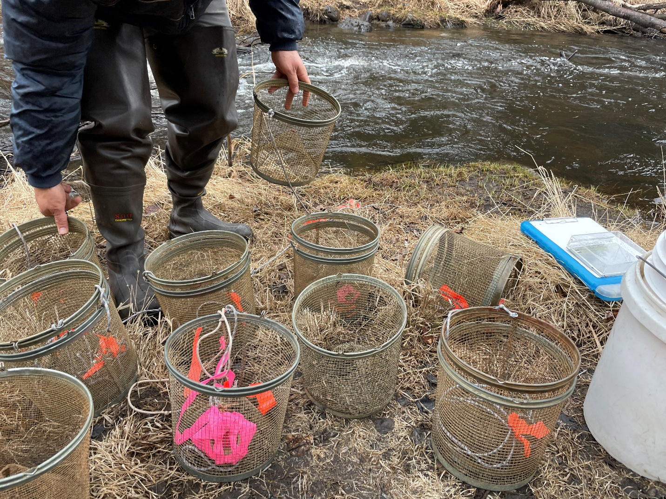

*Minnow traps being prepared at by Trout Unlimited volunteers at a training workshop at Soldotna Creek in June 2021*

### 2.2.1 Minnow Trapping

We used Gee minnow traps baited with salmon eggs as the primary capture methods for juvenile salmonids. We used commercial salmon eggs as bait and placed them in perforated 2-4 oz containers in order to prevent egg consumption by fish. We labeled traps with KWF contact information using brightly colored flagging tape. At the trapping location, we collected site photos and recorded the following on a datasheet: field technician initials, GPS coordinates of trap deployment site(s), and site drawings with pertinent notes regarding fish habitat. We used a minimum of one baited minnow trap, fully submerged in a discrete location, and properly secured to ensure retrieval. We recorded the date and time of deployment. While not exceeding 24 hours, we allowed traps to soak overnight if needed. Upon trap retrieval, we recorded the date and time and transferred the trap’s catch into a bucket of water.

### 2.2.2 Fish processing

We identified each fish that we captured to lowest feasible taxa and life stage using a photarium. We recorded disposition; and in some cases recorded fork length to the nearest millimeter along with photos of identifying features. When completed, we placed fish in a recovery bucket. Once all fish recuperated successfully, we released them near the original capture location. We monitored data throughout the summer for unintended mortalities, and were prepared to cease sampling and contact the area management biologist should >10% unintended collection mortality occur. We entered all data into the Aquatic Resource Permit spreadsheet provided by the ADF&G and submitted it with a written report to ADF&G at the conclusion of each permit year.

These data were used to submit nominations for the inclusion of new miles or acres of fish habitat to the AWC as well as revision or corroboration of fish presence.

## 2.3 Habitat connectivity

In some cases where maps indicated a likelihood of anadromous habitat yet we did not capture salmonids, we visited additional sites within the drainage where potential barriers to fish passage may exist such as road crossings or modified lake outlets. We photographed and recorded coordinates at these locations if potential fish barriers were apparent and submitted them to ADF&G for potential inclusion in their [Fish Passage database](https://www.adfg.alaska.gov/index.cfm?adfg=fishpassage.database).

## 2.4 Data management and analysis

### 2.4.1 Data management

We recorded data in the field using pre-printed Rite-in-the-Rain field forms, and entered data into a [Google Sheets database](https://bit.ly/eas_data)[7]. We read data into RStudio and generated this report using the Quarto book template. Project edits are managed through a dedicated [project GitHub repository](https://github.com/Kenai-Watershed-Forum/salmon-habitat-mapping)[8].

All project documents and data can be accessed in a dedicated [Google Drive folder](https://bit.ly/tu_kwf_embrace_a_stream_2021)[9].

### 2.4.2 Analysis

We generated summary tables displaying the quantity of fish captured at each sample site by date. We also generated a csv file reformatting all fish capture data to prepare for submission to the Alaska Department of Fish and Game to fulfill Aquatic Resource Permit requirements.

# 3  Results

## 3.1 Fish capture

During fieldwork in summers 2021 - 2023:

* Over course of 62 fieldwork days 2021 - 2023 (including the training event), we conducted a total of 108 sampling events at 82 unique sites. See the interactive project map in the Methods section (“[Site selection](https://kenai-watershed-forum.github.io/salmon-habitat-mapping/results.html##%20Site%20selection)”) for a current map of where and when sampling events have occurred.
* Table [Table 3.1](https://kenai-watershed-forum.github.io/salmon-habitat-mapping/results.html#tbl-sites) (Appendix A) summarises total sampling events by individual site. We typically sampled a site only one time each.
* We have captured 3254 fish comprised of 15 unique species. Table [Table 3.2](https://kenai-watershed-forum.github.io/salmon-habitat-mapping/results.html#tbl-ct-spp) summarizes fish capture count by species.
* Table [Table 3.3](https://kenai-watershed-forum.github.io/salmon-habitat-mapping/results.html#tbl-site-spp-ct) (Appendix A) summarizes total fish capture for each species by site.

Table 3.2 – Total capture count by species

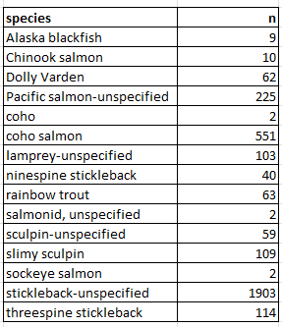

## 3.2 AWC Nominations

Fish capture data was evaluated against the 2021 and 2022 Anadromous Waters Catalog to identify new stream segment nominations. Complete submission materials may be accessed in the project [Google Drive folder](https://drive.google.com/drive/folders/1UmQGruxbmRO-ICCd0xbGi5rPp1ZTFCX2?usp=drive_link)[10]. Nominations were sent to the ADF&G Habitat Division in Anchorage in the fall of each year. As of November 2023, a total length of 28.16 km and 466 lake hectares were included in the nominations.

Table 3.4 breaks down each stream segment nomination by length.

|  | | |
| --- | --- | --- |
| **nomination_name** | **nomination year** | **total_stream_length (km)** |
| Soldotna Creek Parcel | 2021 | 1.01 |
| Beaver Creek Trib 1.3 | 2022 | 2.01 |
| Coal Creek Trib 1 | 2022 | 5.20 |
| Crooked Creek Trib 1.1 | 2022 | 0.19 |
| Funny River Rd Trib 1.1 | 2022 | 1.21 |
| KNWR Trib | 2022 | 3.11 |
| Moose River Trib 1 | 2022 | 3.06 |
| Beaver Creek MT #10 | 2023 | 1.32 |
| Clam Gulch Creek 1 | 2023 | 0.47 |
| Forstner Avenue | 2023 | 1.87 |
| Mackey Lakes Culvert | 2023 | 0.48 |
| Moose River Trib 1 | 2023 | 0.75 |
| Moose River Trib 2 | 2023 | 2.57 |
| Moose River Trib 3 | 2023 | 0.74 |
| Savena Lake Tributary | 2023 | 2.38 |
| Unnamed Kenai Trib 1 | 2023 | 1.89 |

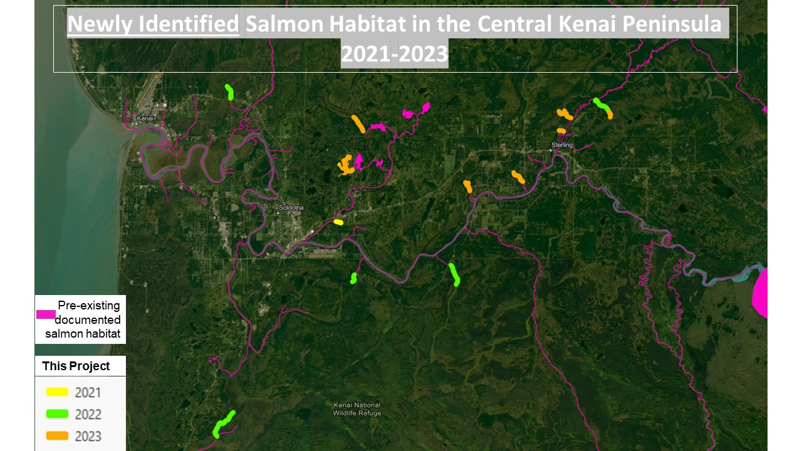

*Figure 3.1: Nominated stream segments highlighted in orange, green, and yellow. Prexisting documented andromous waters prior to this project colored in pink. An interactive version of this map is available on ArcGIS Online at* [*https://experience.arcgis.com/experience/806e59bc0eac4713a26f1f03a76cf85a/?org=KWF*](https://experience.arcgis.com/experience/806e59bc0eac4713a26f1f03a76cf85a/?org=KWF)

For general background on nominations, see the [slides linked here](https://docs.google.com/presentation/d/1uQX9_4T-vJDzp_gzBJFyqtggOg1Fpsng?rtpof=true&usp=drive_fs)[11], presented at Kenai Watershed Forum’s Fireside Chat series held at Kenai River Brewing on November 1, 2023.

## 3.3 Volunteer participation

Volunteer recruitment efforts resulted in a steadily increasing level of participation from the general public (Figure 3.2). A total of 310 volunteer hours were documented throughout the project, with an initial higher outlay in 2021 to initiate training.

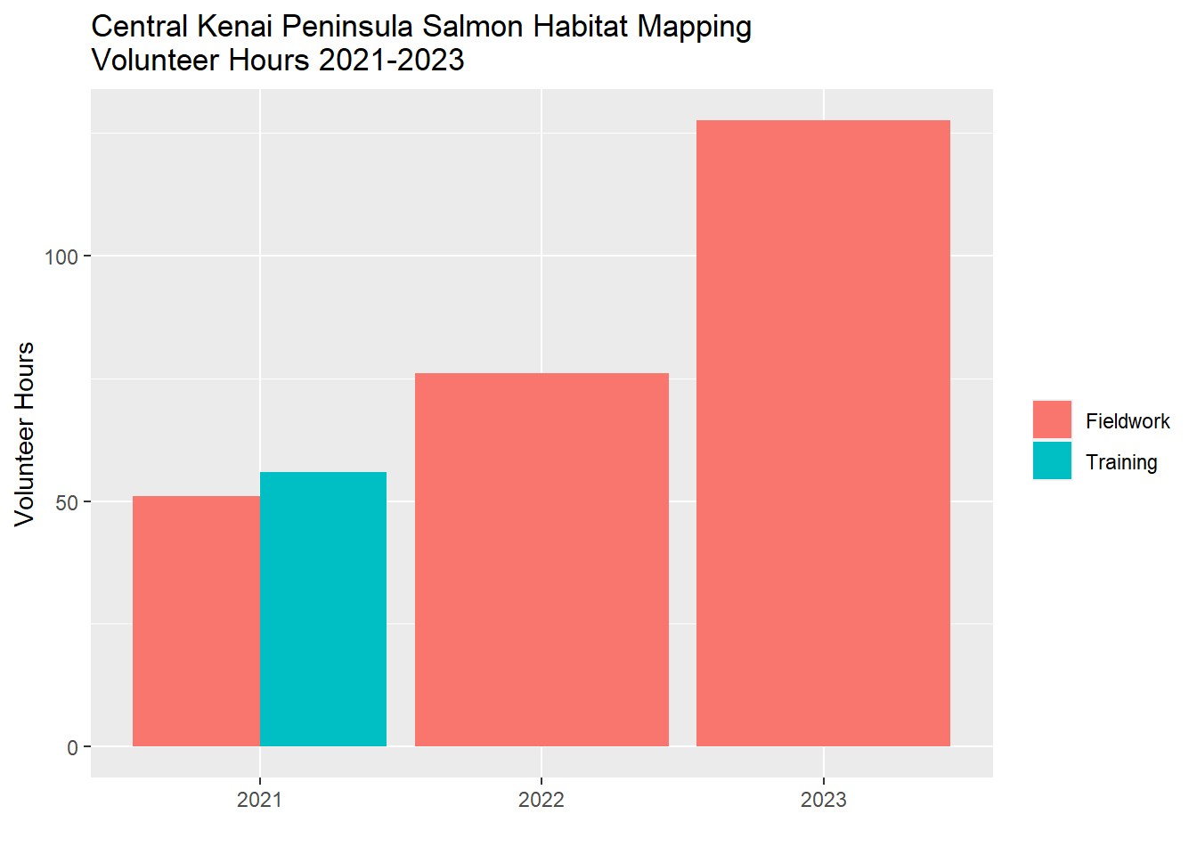

*Figure 3.2 – Volunteer hours for central Kenai Peninsula Salmon habitat mapping.*

The level of volunteer participation, along with experience gained, closely tracked the quantity of nominations submitted each year, with a steadily rising number of nominations from 2021 to 2023 (Figure 3.3).

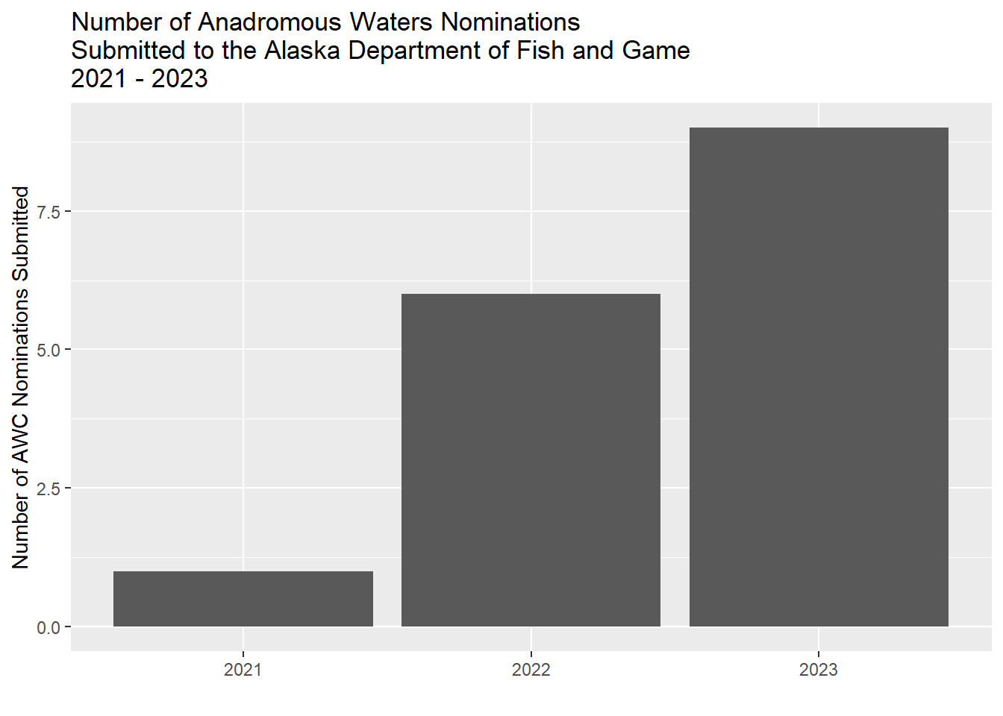

*Figure 3.3 – Number of nominations 2021 - 2023*

## 3.4 Aquatic Resource Permit

Fish capture data was reformatted each fall in to a csv file for submission to ADF&G in fulfillment of the required [Aquatic Resource Permit](http://www.adfg.alaska.gov/index.cfm?adfg=otherlicense.aquatic_reports)[12]; available in the online in this project’s GitHub repository.

# 4  Discussion

Each season of fieldwork was unique, thus we will discuss them individually.

## 4.1 2021 Fieldwork

### 4.1.1 2021 Anadromous habitat surveys

In summer 2021 we surveyed sites primarily in the region North of Kenai/Soldotna within an hour’s walking distance of the road system.

Survey site selections were made by visually assessing the superimposed map layers of the Anadromous Waters Catalog with the [USGS National Hydrography Database](https://www.usgs.gov/core-science-systems/ngp/national-hydrography) (NHD)[13]. In areas where previously documented anadromous stream or lake extents ended but connected water bodies continued upstream, we targeted sites suitable for minnow trapping.

At most sites surveyed in 2021, we captured primarily non-anadromous species such as stickleback and sculpin. We also captured some resident salmonid species such as Dolly Varden and Rainbow Trout.

These results supported several conclusions that directed fieldwork efforts following summer 2022:

* A need exists to refine methods for survey site selection. Relying on visual assessment of overlay between documented AWC habitat and the NHD map is frequently insufficient as a prospecting guide for yet-unidentified anadromous waters. Discussions in Fall 2021 with personnel at ADF&G’s Habitat Division in Anchorage yielded valuable insight and potential for collaboration.
* Some drainages in the North Kenai/Nikiski area that may have been historically anadromous have man-made barriers to fish passage that we identified in Summer 2021. One such example was previously undocumented as was discovered by TU volunteers, discussed further in the section below, “Highlight: Habitat Connectivity.” Identifying fish passage barrier sites is a critical first step in determining if restoration is feasible.

#### 4.1.1.1 2021 Highlight: Lower Soldotna Creek Tributary

KWF was notified of a previously undocumented tributary segment in the Soldotna Creek drainage in July 2021. The tributary was documented as anadromous up to a road crossing approximately 100 m upstream from the Soldotna Creek mainstem, but the stream channel continued beyond. The stream segment upstream of the road crossing had been excavated in June 2021 as part of a new residnetial development project, but it was suspected that the modified channel still supported fish populations. KWF staff placed minnow traps at the most upstream locations where the traps could still be submerged. Over the course of several site visits we captured a total of 65 Coho Salmon and five Dolly Varden.

KWF submitted these data in ADFG’s September 2021 call for data, and documented the approximate paths of existing stream channels, supported by several dozen ground-truthing photos. These data are displayed in the map figure below, and are also accessible at [ArcGIS Online](https://arcg.is/1XO9n5)[14]).

The post-hoc documentation of this previously unidentified salmon stream after it has been altered emphasizes the need for continued thorough efforts to document anadromous habitat, particularly in watersheds experiencing growth and development. Communication with property owners remains critical to the task of identifying previously undocumented anadromous habitat.

#### 4.1.1.2 2021 Highlight: Habitat Connectivity

In two cases where map interpretation suggested presence of salmonids but we captured none, we visited other locations in the watershed where fish barriers may be present. We found evidence of man-made fish barriers at two locations:

1. Suneva Lake - Suneva Lake lies to the North of Daniels Lake in the Nikiski area. The lake’s surface area is appx 1.0 sq km, and flows directly in to Cook Inlet 0.61 km downstream from the lake outlet. Aerial imagery indicates that littoral is ~95% undeveloped. Littoral parcels are primarily privately owned.

We conducted sampling events on two separate days at Suneva lake. We captured stickleback and sculpin on both occasions, but no salmonids despite extensive effort.

We visited the outlet at Suneva lake and discovered two perched culverts installed where the outlet stream crosses Sockeye Avenue ([Figure 4.1](https://kenai-watershed-forum.github.io/salmon-habitat-mapping/discussion.html#fig-suneva-outlet)). The culvert is likely impeding fish passage, as there is a drop of several feet between the stream channel and the culvert outlet.

A site visit to the mouth of the creek flowing from Suneva Lake at its outlet at Cook Inlet will help determine if the waterway has potential to host anadromous species and may be part of future fieldwork.

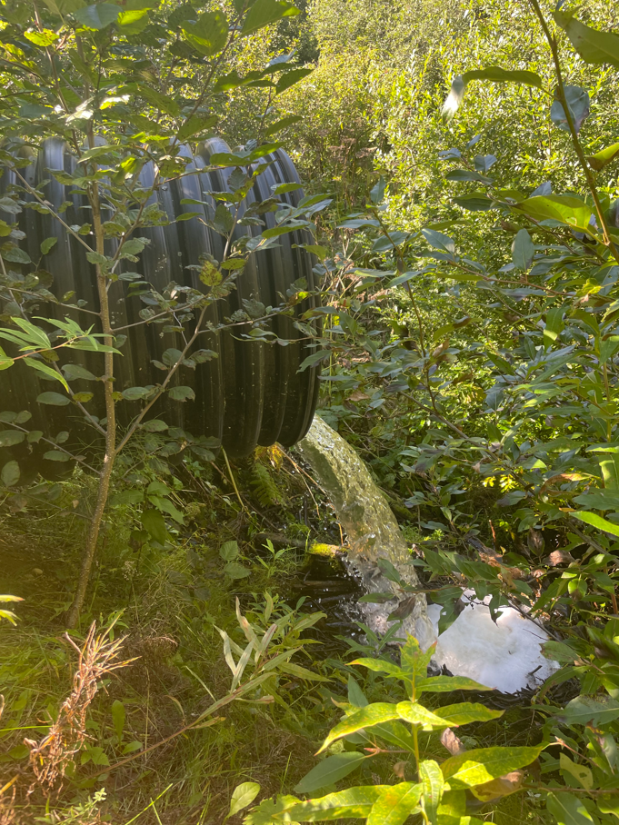

*Figure 4.1: Perched culvert near outlet of Suneva Lake, intersection with Sockeye Avenue*

1. Salamatof Creek - Salatamtof Creek lies North of Kenai and South of Nikiski, crossing the Kenai Spur highway. A stream connection of 1.56 km flows from Lower Salamatof Lake to Cook Inlet, and a stream segment of 2.84 km connects the lower lake to Salamatof Lake. We sampled at a site in the stream segment connecting the two lakes on one occasion in Summer 2021 and captured a several hundred sticklebacks, but no salmonids.

We visited the location where maps indicated that Salamatof Creek crosses the Kenai Spur Highway in August 2021 ([Figure 4.2](https://kenai-watershed-forum.github.io/salmon-habitat-mapping/discussion.html#fig-salamatof-creek)).

At the road crossing we observed a culvert passage for Salamatof Creek below the highway, but no flowing water. The visible nearby body of water at this location appeared to be lotic in nature, and no outflow was readily evident.

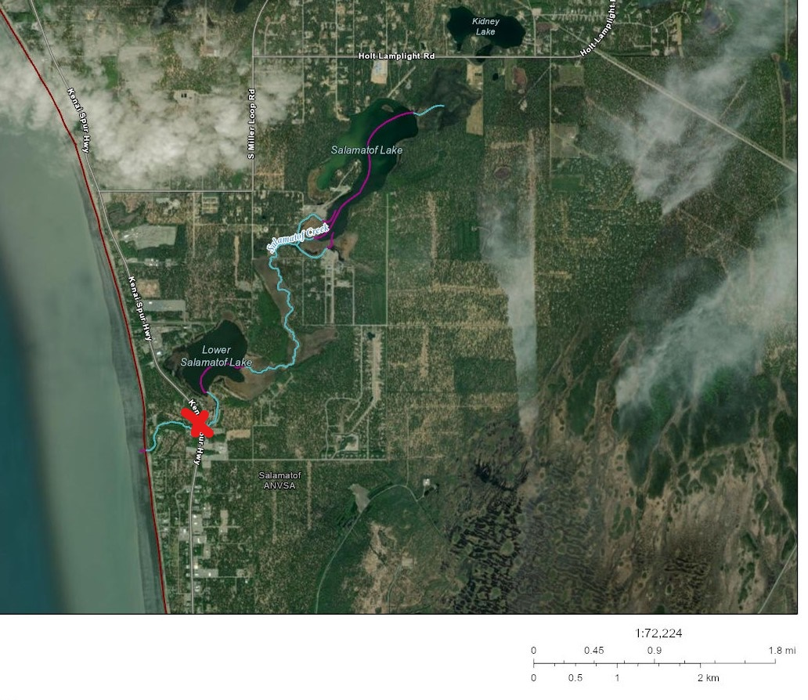

*Figure 4.2: Salamatof Creek drainange, North of Kenai, Alaska. Red X indicates location of fish passage barrier.*

Based on observations at the road crossing, it is possible that historical construction activities altered the flow path of Salamatof Creek such that it no longer connects to Cook Inlet except at very high flow volumes. A review traditional knowledge in this area could help reveal if this watershed may have previously been an anadromous waterbody. Additionally, a review of historical aerial imagery could reveal how channel path or lake acreage extent may have changed in recent decades.

#### 4.1.1.3 2021 Outreach and other activities

In addition to fieldwork efforts aimed at prospecting for unidentified anadromous waters, having personnel mobilized and trained in juvenile fish identification and capture methods allowed for support in two additional efforts:

* **Education**. In 2021 KWF oversaw 12 fish sampling events aimed exclusively at education and outreach, occurring primarily at Lower Soldotna Creek. These events introduced basic facts about wild salmon life history and habitat to local community members, visitors, journalists, and summer campers. Total participants is estimated in excess of one hundred people.
* **Culvert replacement**. In summer 2021 KWF oversaw construction activities to replace the culvert carrying the North Fork of the Anchor River underneath Niklovaesk road in the Anchor Point area. As part of these efforts, a small segment of river channel is temporarily de-watered thus fish in this segment must be captured and released downstream prior. KWF personnel was able to capture n = 329 juvenile fish as part of these fish rescue efforts.

## 4.2 2022 Fieldwork

### 4.2.1 2022 Anadromous Habitat Surveys

In Summer 2022 we focused our survey efforts on streams in the Kenai/Soldotna/Sterling area including Coal Creek, Beaver Creek, and tributaries of the Moose River. Experience from the previous season contributed to much more frequent success of identifying anadromous habitat prior to fieldwork. **In 2022, four out of five site visits yielded fish observations used in AWC nominations.**

In one case, at the “Moose River Trib 1.4” site, the flow line indicated by the National Hydrography Database stops ~0.3 miles downstream of the location where we captured juvenile coho salmon. Thus, this salmon-bearing location was not only not documented in the Anadromous Waters Catalog, it was not yet documented even as a stream ([Figure 4.3](https://kenai-watershed-forum.github.io/salmon-habitat-mapping/discussion.html#fig-moose-trib).)

These observations highlight the need for a more sophisticated mapping approach to generate survey sites for additional fieldwork. For additional discussion and a plan forward on this topic, see the “Next Steps” chapter.

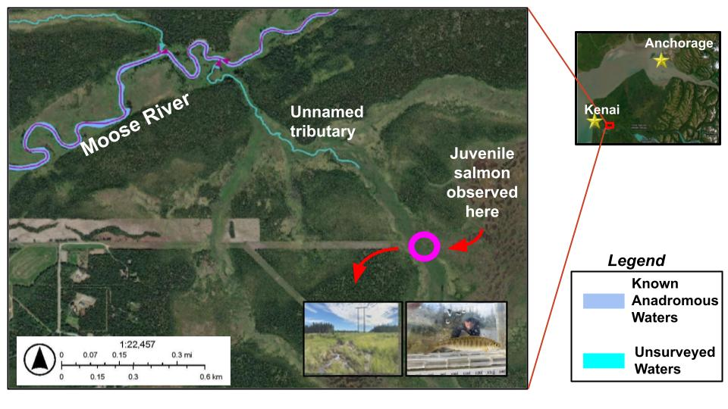

Figure 4.3: A undocumented anadromous tributary of the Moose River near Sterling, AK.

#### 4.2.1.1 2022 Outreach and other activities

* **Education**. In 2022 KWF continued to oversee fish sampling events aimed exclusively at education and outreach, occurring primarily at Lower Soldotna Creek. These events introduced basic facts about wild salmon life history and habitat to local community members, visitors, journalists, and summer campers. Total participants is estimated in excess of one hundred people.

## 4.3 2023 Fieldwork

### 4.3.1 2023 Anadromous Habitat Surveys

In 2023 we continued to focus on waters near the road system in the central Kenai Peninsula including Soldotna Creek, Moose River, Beaver Creek, and smaller unnamed tributaries of the lower main stem Kenai River. **In 2023 nearly all sites that we surveyed revealed the presence of juvenile anadromous fish.**

As presented in the results section, steadily increasing volunteer participation tracked closely with an increasing number of nominations.

## 4.4 2021-2023 Media highlights

### 4.4.1 Radio

From 2021-2023, KDLL Public Radio published three stories about the work discussed in this report:

* [“Groups put area’s anadromous fish on the map”](https://www.kdll.org/local-news/2021-05-28/groups-put-areas-anadromous-fish-on-the-map) (May 27, 2021), reporter Elizabeth Earl
* “[Stream by stream, volunteers map the Kenai Peninsula’s anadromous waters](https://www.kdll.org/local-news/2022-09-02/stream-by-stream-volunteers-map-the-kenai-peninsulas-anadromous-waters)” (September 2, 2022), reporter Sabine Poux ([Figure 4.4](https://kenai-watershed-forum.github.io/salmon-habitat-mapping/discussion.html#fig-radio-story))
* [‘They don’t necessarily look like salmon habitat’; Kenai Watershed Forum maps the Peninsula’s anadromous waters”](https://www.kdll.org/local-news/2023-09-18/they-dont-necessarily-look-like-a-salmon-habitat-kenai-watershed-forum-maps-the-peninsulas-anadromous-waters) (September 18, 2023), reporter Hunter Morrison

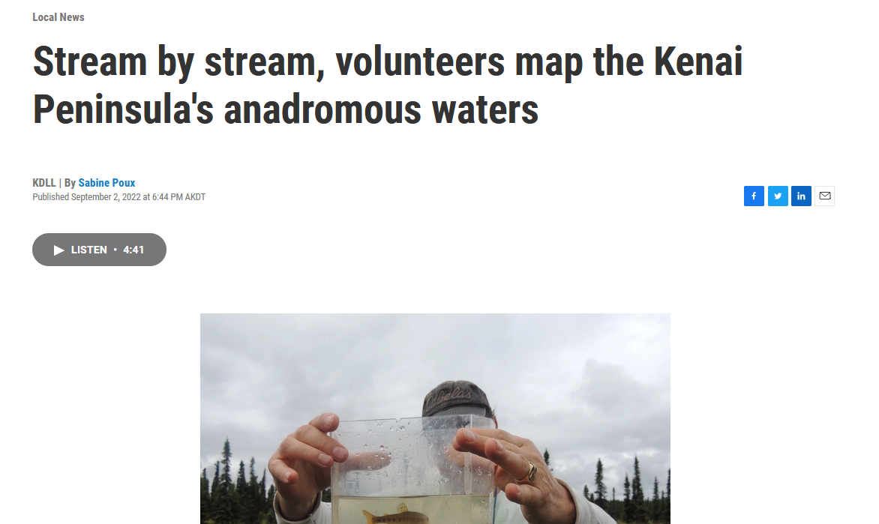

*Figure 4.4: KDLL Radio Story from September 2, 2022*

### 4.4.2 Public Lecture

On November 1, 2023, Alexa Millward (Trout Unlimited) and Benjamin Meyer (Kenai Watershed Forum) were featured to present this project as part of Kenai Watershed Forum’s “Fireside Chats” series held at Kenai River Brewing in Soldotna, AK.

* Presentation slides [available online at this link](https://docs.google.com/presentation/d/1uQX9_4T-vJDzp_gzBJFyqtggOg1Fpsng?rtpof=true&usp=drive_fs)[15]
* Audio lecture [available at this link](https://www.kdll.org/podcast/kenai-conversation/2023-11-15/kenai-conversation-mapping-anadromous-waters)[16], aired on KDLL Radio’s Kenai Conversation on November 15, 2023

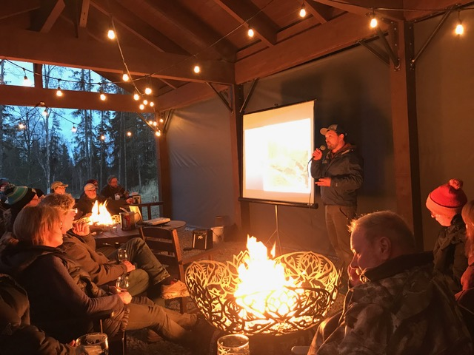

*Benjamin Meyer presents at Kenai Watershed Forum’s Fireside Chat series on November 1, 2023*

# 5  Future Directions

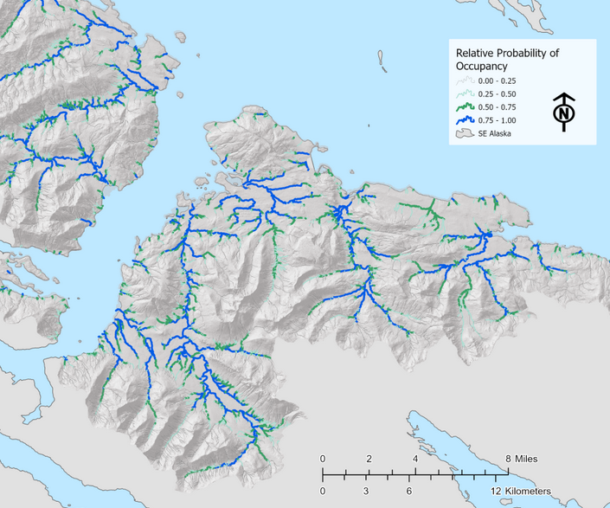

*Figure 5.1: Figure from ‘Southeast Alaska Fish Habitat,’ Romey Fisheries and Aquatic Sciences (2021)’. Color gradients indicate relative probability of anadromous fish presence.*

## 5.1 Summary

Our on-the-ground work serves to strengthen local freshwater habitat conservation and education efforts. However given the likely quantity of remaining undocumented anadromous habitat, going forward it will be critical to use a systematic, targeted fieldwork approach that can inform models for predictive occupancy maps that could one day be used for habitat regulation and management.

The collaboration between the Kenai Peninsula Chapter of Trout Unlimited and Kenai Watershed Forum serves as a compelling example of how to engage volunteers interested in conserving fish habitat with hands-on opportunities. There is great potential to expand and continue the work described in this report, and a great urgency to do so.

The Anadromous Waters nominations generated as a result of this project will play an important role in conserving salmon habitat in the areas we surveyed. The value of educating and engaging volunteer participants is also evident. However in a broader view, the primary take away from this project is the need to re-frame our long term approach for how to discover, document, and conserve anadromous habitat. Our current methods would continue to yield additional AWC nominations, but at a scale and pace insufficient to keep pace with new developments, even with many additional volunteers. The potential to accelerate this work and document hundreds of additional anadromous stream miles on the Kenai Peninsula is ready at hand, and much of the initial groundwork has already been completed and is awaiting financial support.

Ultimately, the driving force behind the work described in this report is the presumption that Alaska freshwater habitat is **not** anadromous, unless anadromous fish have been physically documented. Our results strongly indicate the value of revising this assumption. The relative ease with which we documented over seventeen miles of anadromous stream and a thousand lake-acres within a growing residential area suggests that even our most sincere efforts to ground-truth the presence/absence of anadromous fish will dramatically underestimate their range. In the past, the presumption of non-anadromy may have served to manage the larger, more visually apparent rivers and lakes where adult fish migrate and spawn, but for smaller headwaters and tributaries it puts untold quantities of juvenile rearing habitat at existential risk.

How can we address this risk without putting undue burden on state agency managers, researchers, and permit specialists? It would be ideal if we could easily document each and every end-of-anadromy headwaters location, but given that the physical geography of watersheds is that of a tree-shaped fractal network with progressively smaller upstream headwaters ([Carraro and Altermatt 2022](https://kenai-watershed-forum.github.io/salmon-habitat-mapping/references.html#ref-carraro2022)), it is not a realistic goal. The number of such locations in the Kenai Peninsula Borough alone might number tens of thousands. If we wish to understand the full picture of where fish actually occupy the landscape, clearly another approach is needed.

Today, researchers are developing predictive models that can represent fish occupancy on the freshwater landscape with a high level of accuracy. These models are discussed in further detail below, and also in an essay on Kenai Watershed Forum’s website [(“Mapping Alaska’s Salmon Habitat[17].)”](https://www.kenaiwatershed.org/news-media/mapping-alaskas-salmon-streams/) Currently these models are regionally-focused. In the future, if a successful predictive model can be scaled to the state-wide level, managers and permit specialists may be able to use these maps when reviewing the impacts of proposed development projects. If adopted, such an approach would provide a level of detail that more accurately represents the true range of freshwater fish habitat.

## 5.2 Rationale for Anadromous Waters Mapping in Alaska

As described in Section 1.2 of this report, current Alaska statute is such that rivers, streams, and lakes throughout Alaska are presumed non-anadromous until otherwise demonstrated, thus the need for the hands-on documentation such as that featured in this project. A failed statewide ballot measure initiative in 2018 would have reversed the baseline presumption of non-anadromy, among other changes to salmon habitat regulations[18].

Various state, federal, tribal, private, and non-profit entities have pursued the work of documenting anadromous habitat for decades and contributed to the detail contained within the anadramous waters catalog. When anadromous habitat is undocumented, proposed development on or near these waters will not trigger the need for a Fish Habitat Permit review from ADF&G, which requires impacts to be evaluated along with possible local mitigation requirements such as fish-friendly culverts or enforcement of riparian buffer zones.

This dearth of detailed map information has had consequences particularly in rapidly developing areas. For example, in Summer 2021 a tributary Soldotna Creek was partially excavated and ditched, and was not documented as anadromous until after the fact[19]. Arguably, this outcome would have been less likely had managers or the developer been aware that this salmon stream existed. Another prominent example is when in 2008-2010, dozens of anadromous streams were documented and nominated by The Nature Conservancy directly within the proposed footprint of Pebble Mine; waters that had not been documented by mine consultants conducting baseline assessments[20],[21]. Thus the sooner that currently undocumented anadromous waters are documented, the more likely it is that impacts can be properly evaluated and mitigated prior to development.

## 5.3 Current State of Anadromous Waters Mapping

As described in section 2.1 of this report (Methods: Site Selection), most current fieldwork efforts are prioritized by visually assessing the overlap of stream segments in the Anadromous Waters Catalog and the National Hydrography Database. Communication among regional researchers and managers also helps choose fish survey locations, along with suggestions from the general pubic. Researchers have also used formal oral interviews with traditional knowledge holders to help suggest fish survey locations (Green, 2022).

While all these methods are useful in generating ideas for survey locations, they do not comprise a systematic approach and they are based on incomplete stream network maps. In order for conservation needs to better match the pace of conservation challenges, a more comprehensive approach is needed.

Some efforts toward this end have been initiated in recent years. In the southern Kenai Peninsula, researchers with Kachemak Bay National Estuarine Research Reserve (KBNERR) successfully applied a predictive habitat modeling approach ([King et al. 2012](https://www.journals.uchicago.edu/doi/abs/10.1899/11-109.1)) and added dozens of miles to the AWC from resulting efforts. However, the approach taken by the KBNERR researchers would arguably prove challenging to replicate at broader geographic scales, as it relies on extensive ground truthing of habitat characteristics and flow to produce the predictive models.

Another similar approach to anadromous habitat mapping is currently being applied in southeast Alaska by the U.S. Forest Service and other partners. Using high resolution stream network maps coupled with fish habitat intrinsic potential models, researchers are able to predict the locations of upper extent of anadromy with 98% accuracy with an average error distance of < 67m[22]. For more details see the [StoryMap from Romey Fisheries and Aquatic Sciences](https://storymaps.arcgis.com/stories/6b3949e1ebcd44c6a531d13f038807c5)[23].

Predicting the locations of upper anadromous extent allows researchers to take a more informed approach to prioritzing their fieldwork of documenting anadromous habitat. Researchers in southcentral Alaska should aspire to emulate the approach described in the preceding StoryMap, prioritizing surveys of waters outside the federally managed areas of the Kenai National Wildlife Refuge and Chugach National Forest.

For future long-term efforts to effectively gather field data to be used in AWC nominations, two general research directions are suggested:

1. Application of higher-resolution stream network maps and habitat modeling approaches, such as [NetMap](https://www.fs.usda.gov/pnw/tools/netmap)[24]
2. Evaluation of “success rates” in prospecting for anadromous sites. E.g., how frequently, when, and where do predictions undocumented anadromous habitat prove correct?
3. Formal and frequent communication and collaboration among entities conducting anadromous habitat survey work

The combination of these approaches outlines a collaborative “ground-truthing” type approach to AWC mapping, where remote sensing data is used to make predictions that are then refined by field observations.

Given the near-perfect rate of predictions thus far using the predictive modeling approach, in the future these maps of stream segments predicted to be anadromous might be used by managers when evaluating environmental impacts and the need for permitting and mitigation – pending

## 5.4 Next Steps

To follow though on the recommendations above, a dedicated research project is being developed and executed in cooperation with subject experts. The following steps describe a path forward:

1. **Evaluate existing NetMap coverage for the Kenai Peninsula Borough**
   * NetMap was commissioned for the Chugach National Forest in 2017, and Kenai Peninsula coverage extends from the Prince William Sound / Turnagain Arm region to the western boundary with Kenai National Wildlife Refuge. The shapefiles are available by contacting Kenai Watershed Forum or Romey Fisheries and Aquatic Sciences.
   * LiDAR, a geospatial dataset needed to produce the NetMap stream layers, already has complete coverage for the Kenai Peninsula Borough region.
   * In Summer 2024, the Kenai Peninsula Chapter of Trout Unlimited and Kenai Watershed Forum will conduct fieldwork to evaluate the efficacy of the End-of-Anadromy model developed by Romey Fisheries and Aquatic Sciences for in southeast Alaska. This work is supported by an additional Trout Unlimited Embrace-a-Stream grant awarded to the chapter in Fall 2023.
   * If the approach of applying the end-of-anadromy model for the Chugach National Forest region proves successful, we will pursue funding to expand this approach to the broader Kenai Peninsula Borough region and beyond.
2. **Develop, communicate, and maintain a prioritized list of fish habitat survey sites shared among multiple agencies**
   * Once a list of locations of predicted Upper Extent of Anadromy is generated using the NetMap layer, regional experts can use their knowledge of local conservation priorities to prioritize which sites should be surveyed first. This step will involve both a GIS based approach for tasks such as identifying parcel ownership status where sites are located, as well as a consensus/discussion based approach to apply knowledge of local conservation priorities and planning efforts.
   * Site survey responsibilities will be assigned to participating organizations. Once complete, preliminary results will be recorded in a shared database to minimize redundant site visits.
3. **Recruit and train participants from agency employees and volunteers**
   * Entities known to currently be engaged in the work of AWC nominations in the Kenai Peninsula region include the following, but are not limited to:
     + Alaska Department of Fish and Game Habitat Division
     + Kenai Soil and Water Conservation District
     + U.S. Fish and Wildlife Service
     + Kenai Watershed Forum
     + Kachemak Bay National Estuarine Research Reserve
     + Kenai Peninsula Chapter of Trout Unlimited
     + University of Alaska
   * Training sessions would be offered to encourage participation from the general public
   * Employing a consistent, user-friendly, collaborative method of data collection will be critical to implementing this project on a larger scale. ADF&G requires that AWC nominations are supervised by a “qualified biologist,” thus careful and systematic review of nomination data prior to submission will be essential. Use of a custom-designed ESRI Survey123 app is likely the most appropriate choice for this task. The smartphone app “[Fish Map App](https://alaskafishmapping.org/)”[25] developed by the [Indiginous Sentinals Network](https://www.sentinelsnetwork.org/) also shows potential to be highly useful in this process; though currently the app is not yet designed to record some essential information for juvenile surveys, such as gear effort.
   * A high degree of location accuracy (<1m) is required for ground-truthing NetMap data. Expensive options such as Trimble hand held devices may be inaccessible, thus it is suggested to train participants to use bluetooth accessory receivers (e.g. [Bad Elf GNSS Surveyor](https://bad-elf.com/pages/be-gps-3300-detail)) when recording coordinates.

Many other regions of Alaska have already had synthetic stream networks developed and mapped. Following the success of the work proposed above, the approach would be able to be replicated state-wide.

## 5.5 Final Words

While this report shows how much has been accomplished in documenting local salmon habitat, it is clearer than ever how much remains to be accomplished. We are grateful for the help and support of the dozens of volunteers involved with making this project happen and we look forward to continuing our efforts together.

# References

Carraro, Luca, and Florian Altermatt. 2022. “Optimal Channel Networks Accurately Model Ecologically-Relevant Geomorphological Features of Branching River Networks.” Communications Earth & Environment 3 (1): 1–10. <https://doi.org/10.1038/s43247-022-00454-1>.

Green, D. Alaska Department of Fish and Game, February 21, 2022. Personal communication.

King, Ryan S., Walker, Coowe M., Whigham, Dennis F., Baird, Steven J., and Back, Jeffry A. 2012. “Catchment topography and wetland geomorphology drive macroinvertebrate community structure and juvenile salmonid distributions in south-central Alaska headwater streams.” Freshwater Science 31 (2): 341-364. <https://doi.org/10.1899/11-109.1>.  
  
Romey Fisheries & Aquatic Science. 2021. Southeast Alaska Fish-Habitat. <https://storymaps.arcgis.com/stories/6b3949e1ebcd44c6a531d13f038807c5>.

**Appendix A – Supplemental Tables**

Table 3.1 – Site Visits (page 1 of 3)

|  |  |  |  |
| --- | --- | --- | --- |
| **site** | **latitude** | **longitude** | **site_visits** |
| Beaver Creek MT #10 | 60.61714 | -151.09225 | 2 |
| Beaver Creek Trib 1.1 | 60.57007 | -151.14650 | 1 |
| Beaver Creek Trib 1.2 | 60.57484 | -151.15033 | 1 |
| Beaver Creek Trib 1.3 | 60.57522 | -151.15081 | 1 |
| Bernice Culvert | 60.69047 | -151.38359 | 1 |
| Bird Lake | 60.98049 | -150.41368 | 1 |
| Bird Pond | 60.98346 | -150.41749 | 1 |
| Candlelight - Downstream | 60.56958 | -151.19272 | 1 |
| Candlelight - Upstream | 60.56990 | -151.19318 | 1 |
| Clam Gulch Creek 1 | 60.23948 | -151.40024 | 1 |
| Coal Creek Trib 1 | 60.38256 | -151.14365 | 2 |
| Coal Creek Trib 2.1 | 60.34428 | -151.22014 | 1 |
| Colorado Creek 1 | 60.64451 | -149.50086 | 1 |
| Crooked Creek Trib 1.1 | 60.30811 | -151.28239 | 1 |
| Crooked Creek Trib 1.2 | 60.31038 | -151.28288 | 1 |
| Derks Lake Outlet | 60.53088 | -150.97156 | 1 |
| Dolly Varden Way - Downstream | 60.52771 | -150.98445 | 1 |
| Dolly Varden Way - Upstream | 60.52770 | -150.98457 | 1 |
| East Mackey Lake | 60.53527 | -150.99130 | 1 |
| Forestner Culvert - Downstream | 60.52387 | -150.80682 | 1 |
| Forestner Culvert - Upstream | 60.52383 | -150.80687 | 1 |
| Funny River Rd Trib 1.1 | 60.45978 | -151.00067 | 1 |
| Kasilof Trib 1.1 | 60.33330 | -151.27026 | 1 |
| Kasilof Trib 1.2 | 60.33295 | -151.27072 | 1 |
| Kasilof Trib 2 | 60.32300 | -151.29253 | 1 |
| KNWR Trib 1 | 60.45829 | -150.87640 | 1 |
| Lief Hansen Park | 60.55368 | -151.24632 | 1 |
| Lou Morgan Crossing - Downstream | 60.51299 | -150.85959 | 1 |
| Lou Morgan Crossing - Upstream | 60.51336 | -150.85987 | 1 |
| Lower Beaver Creek | 60.56008 | -151.12611 | 1 |
| Lower Soldotna Creek | 60.48340 | -151.05767 | 13 |
| Mackey Lakes Crossing - Downstream | 60.52515 | -151.00233 | 1 |
| Mackey Lakes Crossing - Upstream | 60.52515 | -151.00233 | 1 |
| Mackey Lakes Culvet - Downstream | 60.52523 | -151.00211 | 1 |
| Makey Lakes Culvert - Upstream | 60.52508 | -151.00254 | 1 |
| McLain Lake NE | 60.86992 | -150.57885 | 1 |
| Table 3.1 Continued (page 2 of 3) |  |  |  |
| **site** | **latitude** | **longitude** | **site_visits** |
| Moose River Trib 1 | 60.56372 | -150.70284 | 1 |
| Moose River Trib 1.2 | 60.56126 | -150.69427 | 1 |
| Moose River Trib 1.3 | 60.56302 | -150.69737 | 2 |
| Moose River Trib 1.4 | 60.56000 | -150.69296 | 2 |
| Moose River Trib 1.4 | 60.56006 | -150.69288 | 2 |
| Moose River Trib 1.5 | 60.55808 | -150.69173 | 1 |
| Moose River Trib 1.6 | 60.55702 | -150.69170 | 1 |
| Moose River Trib 1.7 | 60.55654 | -150.69141 | 1 |
| Moose River Trib 2 | 60.55982 | -150.70920 | 1 |
| Moose River Trib 2.1 | 60.55926 | -150.74504 | 1 |
| Moose River Trib 2.2 | 60.56039 | -150.75308 | 1 |
| Moose River Trib 2.3 | 60.56094 | -150.74669 | 1 |
| Moose River Trib 3.1 - Downstream | 60.54928 | -150.75262 | 1 |
| Moose River Trib 3.1 - Upstream | 60.54928 | -150.75262 | 1 |
| Moose River Trib 3.2 | 60.55289 | -150.76065 | 1 |
| North Fork Anchor River | 59.80044 | -151.63683 | 1 |
| North Nikiski Lake 1.1 | 60.80209 | -150.99556 | 1 |
| North Nikiski Lake 1.2 | 60.79753 | -150.98597 | 1 |
| North Nikiski Lake 2 | 60.79426 | -150.98744 | 1 |
| Poppy Lane Creek | 60.49551 | -151.21537 | 1 |
| Salamatof Creek | 60.63943 | -151.31749 | 1 |
| Savena Lake Trib | 60.55695 | -150.99910 | 1 |
| Seven Egg Creek | 60.93470 | -150.71312 | 1 |
| Snag Lake South | 60.81345 | -150.69006 | 1 |
| Soldotna Creek Mouth | 60.48339 | -151.05813 | 6 |
| Soldotna Creek Parcel | 60.49508 | -151.01560 | 4 |
| Soldotna Creek Parcel | 60.49537 | -151.01497 | 4 |
| Soldotna Creek Parcel | 60.49496 | -151.01456 | 4 |
| Soldotna Creek Parcel | 60.49453 | -151.01456 | 4 |
| soldotna_creek2 | 60.54188 | -150.92760 | 1 |
| South Mackey Pond | 60.52231 | -151.00756 | 2 |
| Summit Lake Outlet | 60.64235 | -149.49396 | 1 |
| Suneva Lake | 60.75166 | -151.19413 | 2 |
| Tree Lake | 60.55918 | -150.91839 | 1 |
| Unknown Nikiski Creek 1 | 60.77920 | -151.08126 | 1 |
| Unknown Nikiski Lake 1 | 60.77243 | -151.08656 | 1 |
| Unknown Nikiski Lake 2 | 60.76791 | -151.07202 | 1 |
| Unnamed Kenai Trib 1 - Upstream | 60.52016 | -150.86489 | 1 |
| Unnamed Kenai Trib 1.1 | 60.51832 | -150.86528 | 1 |
| Table 3.1 Continued (page 3 of 3) |  |  |  |
| Unnamed Kenai Trib 1.2 | 60.51828 | -150.86191 | 1 |
| Upper Ohmer Lake | 60.45573 | -150.28566 | 1 |
| Upper Savena Lake Trib | 60.56934 | -151.03661 | 1 |
| Upper Soldotna Creek 1 | 60.55580 | -150.92282 | 1 |
| WalMart Creek | 60.56560 | -151.22130 | 2 |
| WalMart Creek | 60.56561 | -151.22133 | 2 |
| West Beck Lake 1 | 60.72683 | -151.14131 | 1 |
| West Beck Lake 2 | 60.72763 | -151.14376 | 1 |
| West Fork Beaver Creek Bridge - Downstream | 60.64054 | -151.08395 | 1 |
| West Fork Beaver Creek Bridge - Upstream | 60.64064 | -151.08405 | 1 |
| West Mackey Lake | 60.52338 | -151.00732 | 1 |
| West Mackey Lake 2 | 60.52371 | -151.00665 | 1 |

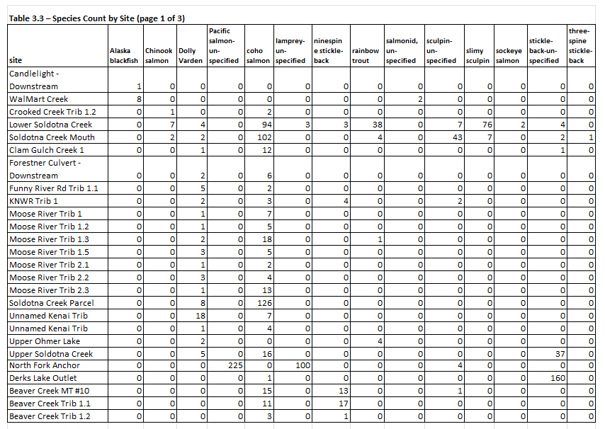

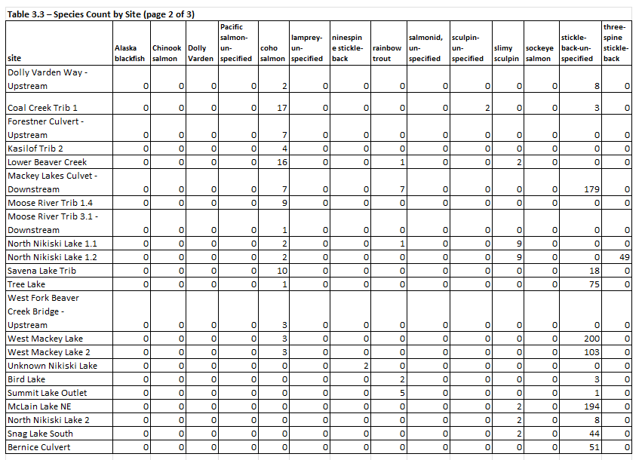

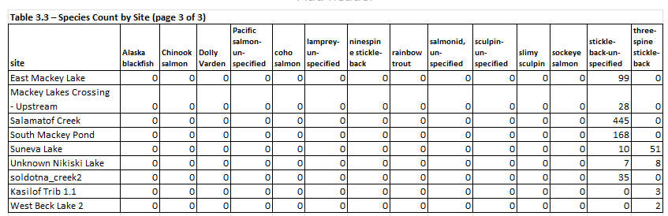

1. <http://www.adfg.alaska.gov/index.cfm%3Fadfg=habitatregulations.prohibited>[↩︎](https://kenai-watershed-forum.github.io/salmon-habitat-mapping/intro.html#fnref1)  
   2 <https://www.adfg.alaska.gov/sf/SARR/AWC/index.cfm?ADFG=main.home>[↩︎](https://kenai-watershed-forum.github.io/salmon-habitat-mapping/intro.html#fnref2)

  
2.
3. <https://www.adfg.alaska.gov/sf/SARR/AWC/index.cfm?ADFG=nomSubmit.about>↩︎
4. <https://bit.ly/kwf_awc_sop>[↩︎](https://kenai-watershed-forum.github.io/salmon-habitat-mapping/intro.html#fnref4)
5. <https://www.kenaifishpartnership.org/cap/>[↩︎](https://kenai-watershed-forum.github.io/salmon-habitat-mapping/methods.html#fnref1)
6. <https://experience.arcgis.com/experience/806e59bc0eac4713a26f1f03a76cf85a/?org=KWF>
7. <https://bit.ly/eas_data>[↩︎](https://kenai-watershed-forum.github.io/salmon-habitat-mapping/methods.html#fnref3)
8. <https://github.com/Kenai-Watershed-Forum/salmon-habitat-mapping>[↩︎](https://kenai-watershed-forum.github.io/salmon-habitat-mapping/methods.html#fnref4)
9. <https://bit.ly/tu_kwf_embrace_a_stream_2021>[↩︎](https://kenai-watershed-forum.github.io/salmon-habitat-mapping/methods.html#fnref5)
10. <https://drive.google.com/drive/folders/1UmQGruxbmRO-ICCd0xbGi5rPp1ZTFCX2?usp=drive_link>
11. <https://docs.google.com/presentation/d/1uQX9_4T-vJDzp_gzBJFyqtggOg1Fpsng/edit#slide=id.p1>
12. <http://www.adfg.alaska.gov/index.cfm?adfg=otherlicense.aquatic_reports>[↩︎](https://kenai-watershed-forum.github.io/salmon-habitat-mapping/results.html#fnref1)
13. <https://www.usgs.gov/core-science-systems/ngp/national-hydrography>[↩︎](https://kenai-watershed-forum.github.io/salmon-habitat-mapping/discussion.html#fnref1)
14. <https://arcg.is/1XO9n5> [↩︎](https://kenai-watershed-forum.github.io/salmon-habitat-mapping/discussion.html#fnref2)
15. <https://docs.google.com/presentation/d/1uQX9_4T-vJDzp_gzBJFyqtggOg1Fpsng/edit#slide=id.p1>
16. <https://www.kdll.org/podcast/kenai-conversation/2023-11-15/kenai-conversation-mapping-anadromous-waters>
17. <https://www.kenaiwatershed.org/news-media/mapping-alaskas-salmon-streams/>
18. <https://ballotpedia.org/Alaska_Ballot_Measure_1,_Salmon_Habitat_Protections_and_Permits_Initiative_(2018)>[↩︎](https://kenai-watershed-forum.github.io/salmon-habitat-mapping/future_directions.html#fnref1)
19. <https://bookdown.org/kwfwqx/awc_expansion/discussion.html#highlight-soldotna-creek-tributary>
20. <https://www.adn.com/alaska-news/article/salmon-documented-streams-top-pebble-prospect/2011/04/27/>
21. <http://www.pebblescience.org/pdfs/FishSurveysinNushagak%20and%20Kvichakheadwaters.pdf>
22. <https://paperpile.com/shared/ndARhr>
23. <https://storymaps.arcgis.com/stories/6b3949e1ebcd44c6a531d13f038807c5>[↩︎](https://kenai-watershed-forum.github.io/salmon-habitat-mapping/future_directions.html#fnref8)
24. <https://www.fs.usda.gov/pnw/tools/netmap>[↩︎](https://kenai-watershed-forum.github.io/salmon-habitat-mapping/future_directions.html#fnref9)
25. <https://alaskafishmapping.org/>[↩︎](https://kenai-watershed-forum.github.io/salmon-habitat-mapping/future_directions.html#fnref10)